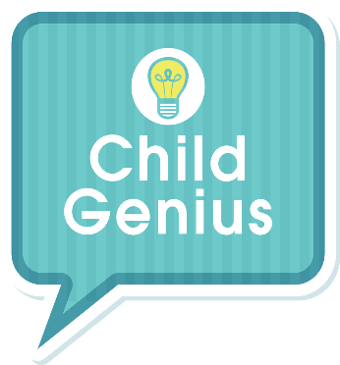
CHILD GENIUS
APPLICATION FORM

Please complete all questions in as much detail as possible and email your completed application form to: child.genius@walltowall.co.uk

Or, please post it to the below address:
Child Genius Casting, Wall to Wall Media Limited, 85 Grays Inn Road, London, WC1X 8TX

WE CANNOT ACCEPT APPLICATIONS FROM CHILDREN – A PARENT OR LEGAL GUARDIAN MUST FILL OUT THE APPLICATION FORM.

Parent/guardian full name
Child’s first name
Child’s date of birth and age
Child’s current school year
Parent/guardian address
Parent/guardian home phone number
Parent/guardian mobile phone number
Parent/guardian email address
Parent(s)/guardian(s) occupations
Do you have other children? If so, what are their ages?

Tell us about your child – what makes you think he or she is gifted? Please give full and detailed answers

Tell us about any achievements and awards.

How would you describe your child’s character?

What would you say are the high points of having a gifted child?

And when do you feel it can be a challenge?

Why would you like to take part in Child Genius?

And why do you think your child would like to take part?

Is there anything else you would like to tell us about your child or your family?

Have you seen previous episodes of Child Genius on Channel 4? What did you think when you watched them?

Where did you hear about the new series?

PLEASE CONFIRM YES/NO (DELETE AS APPROPRIATE), THAT:

- You have read and agreed to the Application Terms and Conditions.

- You have read, acknowledge, understand and agree to the Child Genius Selection Process which is found on the Child Genius Casting Webpage.

- You consent to us (Wall to Wall Media Limited) processing any sensitive personal data that you have provided in your application or as part of the application process on behalf of you/ your child. This processing is necessary for us to consider your/your child’s suitability for the Programme. For more information on how we process personal and sensitive personal data, please see our privacy notice available at:
https://www.walltowall.co.uk/Tv_Production_Privacy.aspx

If you have any questions about how we process your personal data, or would like to withdraw this consent, please use the contact details in the privacy notice.

APPLICATION TERMS AND CONDITIONS

1. By completing and submitting the Application Form (including any photograph(s) or video chat recordings you and your child have participated in and submitted as part of the selection process), you grant to us on behalf of you and your child all necessary rights and consents to permit us to make the fullest use of any information and photographic/recorded material submitted by you on behalf of you and your child as part of your application for any purposes connected with the casting of the Programme.

2. All families must be residents of the UK.

3. Only children who are between the ages of 8 and 12 on or including 18th August 2019 (the date of the Competition Final) are eligible to take part.

4. We cannot accept applications from parents or their close family members who are, or have in the last two years been: (i) an employee or director of Wall to Wall or Channel 4 or any of their respective parent, subsidiary, affiliated or related entities: or (ii) substantively involved in the production of the Child Genius programme or competition.

6. We reserve the right at all times in our absolute discretion to change any part of the application process, including without limitation, eligibility, the structure, content and dates as we see fit.

7. If your child is successful in being selected to take part in the series, you will be required to sign a participant agreement which will set out in greater detail the terms and conditions of yours and your child’s participation in the series.

8. There is no commitment to take part in the series at this initial application stage.

9. The producer’s and broadcaster’s decision is final.

10. THE CLOSING DATE FOR ALL COMPLETED APPLICATIONS IS 13TH MAY 2019.

Thank you for registering your interest in Child Genius.

From the Child Genius team

